PROBLEM-FIT-STATEMENT

**5.**

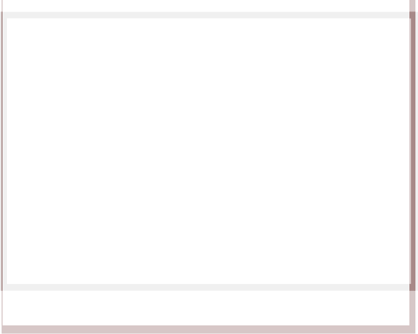

**1.Sementation of customers:**

The glossary provides the data architecture that make you to segment your users based on commonalities in their lifestyle and behaviours.

**4.Problems:**

To resolve customer problem immediately and to provide intimation during illegal activities.

**7.Triggers**:

They tend to meet the customer in a particular geographical locality. This provides indication about the customer.

**8.Feelings**

The popularity to customer care can be achieved through social media which provides effective interaction. The emotion of the customer should be detected and analyzed automatically.



1. **Constraints to customer:**
   * The customer care maintains good conservation by replying to the questions from customers.
   * The customers are supported by website, chatbots or customer agents.

**5.Source:**

In order to meet the customer expectations companies are providing high pressure to improve their relationship with customer.

9.**Solution**:

The machine learning based customer care respond at faster rate and gather much information about their needs. They can be able to identify illegal access of the data. They provide multichannel interaction.



**10**.**Channels available**:

The omnichannel method has been adopted with enhanced digital channel and communication channel.

By which, multiple channels can interact such as email, social media, call enter and webchats.

**6.Behaviour:**

Behaviour dependent CSP customer provide two-value proposition for a communications service provider: correlating Net Promoter Score (NPS) by feedback from customer and understanding customer requirements.

**Solution available:**

* Providing information about illegal calls.
* Notification on validity of their recharge.
* Use language that user can understand.